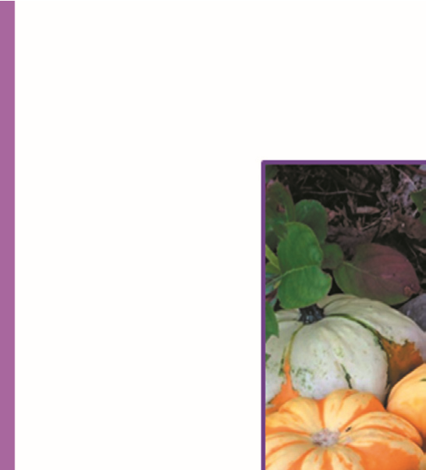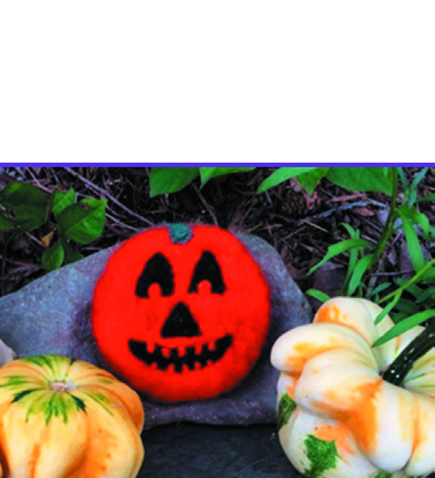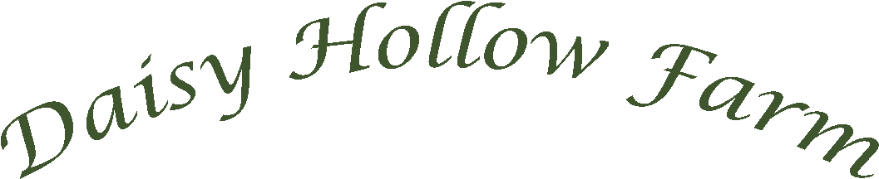

| Costume Contest | Pony Rides

Trick-or-Treating



*All-natural & Hand-crafted*

*Happy “Hollow”een Fun on the Farm*

*October 30 & 31, 2021 / 12PM - 5PM*

*Daisy Hollow Rd, Dryden, NY,*

*13053*

*830*



**• Come out to the farm on Halloween decked out in your best costume! Prizes for**

**best costume for under 13 and 13+**

**• Go on a scavenger hunt around the farm to seek out ghoulish guests giving out**

**goodies...remember to say “trick-or-treat!”**

**• Take a photo with a ghostly goat or a spooky sheep**

**• Stop into our Country Store brimming with farm-fresh edibles and hand-crafted**

**delights**



**Farm and Country Store Hours**

**Wednesday-Saturday: 12pm – 5 pm**



**www.daisyhollowfarm.com | (607) 423-6827**